**TESLA MODEL S P85**

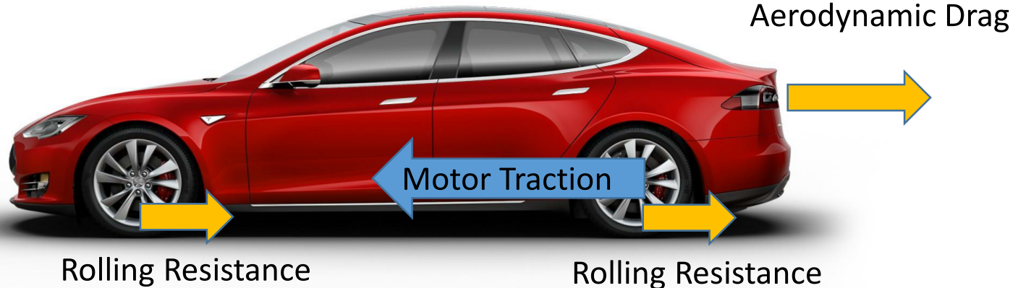

|  |  |  |  |
| --- | --- | --- | --- |
| **CAR CHARACTERISICS** | | | |
| Torque: | 600 Nm at 0 RPM | Power: | 460 HP/343 kW at 8600 RPM |

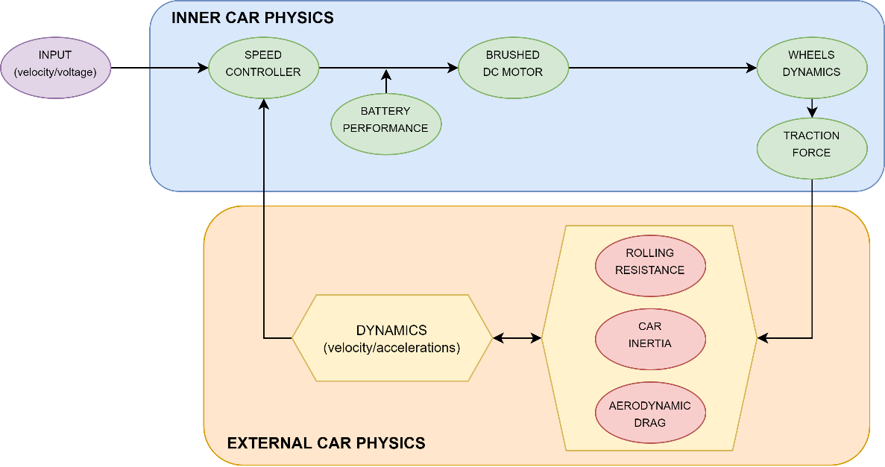

|  |  |  |
| --- | --- | --- |
| **BATTERY PERFORMANCE** | | |
| 16 modules wired in series containing 6 groups of 74 cells wired parallel | Cell Nominal Voltage: | 3.6 V |
|  | | |

|  |  |  |  |  |
| --- | --- | --- | --- | --- |
| **BRUSHED DC MOTOR** | | | | |
| Electromotive Force: | $$E\left(t\right)=K_{E}∙ω(t)$$ | | | |
| Voltage (Time domain): | $$V\left(t\right)=I\left(t\right)∙R+L\frac{dI\left(t\right)}{dt}+E\left(t\right) ⇒ V\left(t\right)=I\left(t\right)∙R+L\frac{dI\left(t\right)}{dt}+K_{E}∙ω(t)$$ | | | |
| Voltage (Laplace domain): | $$V\left(s\right)=I\left(s\right)∙R+s∙L∙I\left(s\right)+K_{E}∙ω(s)$$ | | | |
| Motor Torque: | $$T\left(t\right)=K_{T}∙I\left(t\right), T\left(s\right)=K_{T}∙I\left(s\right) ⇒ T\left(s\right)=K_{T}∙\frac{V\left(s\right)-K_{E}∙ω(s)}{s∙L+R}$$ | | | |
| From Data Sheet: | $$R=5.3∙{10}^{-3} Ohm$$ | $$L=493∙{10}^{-9} Henrys$$ | $$K_{E}=0.12 {Vs}/{rad}$$ | $$K_{T}=0.25 {Nm}/{Amp}$$ |

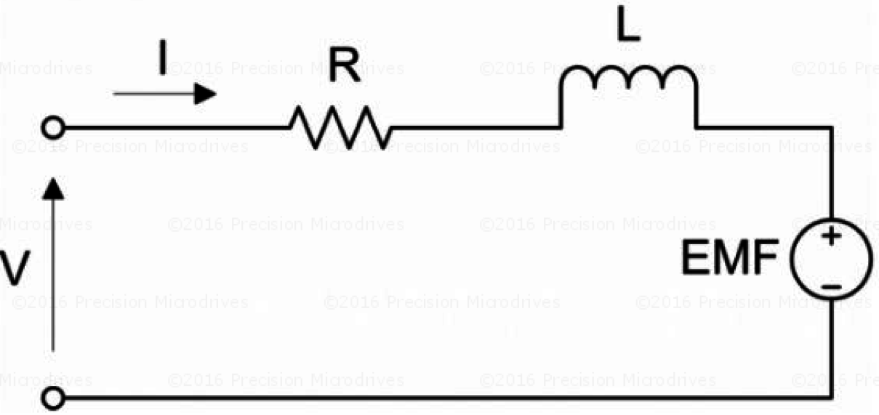

|  |  |  |
| --- | --- | --- |
| **TRACTION FORCE** | | |
| Wheel diameter: | $$2L=48 cm$$ |  |
| Gear ratio: | $$G_{r}=9.73$$ |
| Overall Efficiency: | $$η=0.70$$ |
| Resultant Force: |  |

|  |  |  |  |
| --- | --- | --- | --- |
| **AERODYNAMIC DRAG** | | | |
| Drag Coefficient: | $$C_{D}=0.24$$ | Frontal Area: | $$A=2.34 m^{2}$$ |
| Density at the sea level: | $$ρ=1.225 {kg}/{m^{3}}$$ | Drag force: |  |

|  |  |  |  |  |  |
| --- | --- | --- | --- | --- | --- |
| **ROLLING RESISTANCE** | | | | | |
| Car mass: | $$m=2100 kg$$ | Rolling Resistance Coefficient: | $$C_{r}=0.02$$ | Rolling Force: | $$F_{R}=C_{r}∙m∙g$$ |

